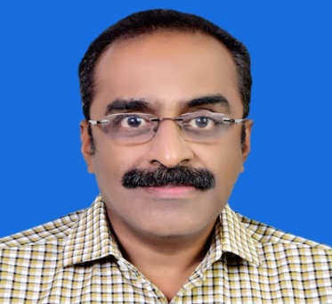
Bio-data
Shri. Jayan N is currently the Director, LPSC (Additional charge) as well as Associate Director, LPSC.
Completed B.Tech in Mechanical engineering from Govt. College of Engineering, Trivandrum and ME in Aerospace engineering from Indian Institute of Science, Bangalore.
Joined LPSC, ISRO in 1992. Worked in the Vikas engine design for the first 8 years. Contributed for the development of the first indigenous Cryogenic engine used in the upper stage of GSLV and led the team which developed the high thrust upper stage cryogenic engine and CE20 engine, for LVM3. Worked as Group Director, Cryogenic & Semicryogenic Propulsion Engines Group & Associate Project Director, GSLV and also as the first Project Director of LOX Methane Engines – Key Technology Project. Became Deputy Director, Earth Storable Engines and stages (ESES). He was transferred to VSSC and elevated as Project Director, Next Generation Launch Vehicle (NGLV) before assuming his present post.
Received the following awards
- The most prestigious Rashtriya Vigyan Puraskar under the category Vigyan Shri for the year 2025
- Space gold medal-2009 from the Astronautical society of India for the meritorious contributions for the Indian Space Programme.
- ISRO team award-2008, 2013 and 2016 for the successful development testing of first indigenous cryogenic stage and engine testing.
- M/s Sabitha Chowdhary memorial endowment and gold medal for the best outgoing student from the Dept. of Aerospace engg:, Indian Institute of science, Bangalore.
- Col.P.Vaidyanathan endowment for the best outgoing student from the Dept. of Mechanical engineering, college of Engg:, Trivandrum.
More than 50 publications in International and National Journals and Conferences.

Updated as on 01.05.2026

